Using BigQuery to query the London Bicycle (Google Data Analytics Certification)

--Number of Bike rides that were greater than 20 minutes

SELECT count(*) as num_of_trips

FROM `bigquery-public-data.london_bicycles.cycle_hire`

WHERE duration>1200

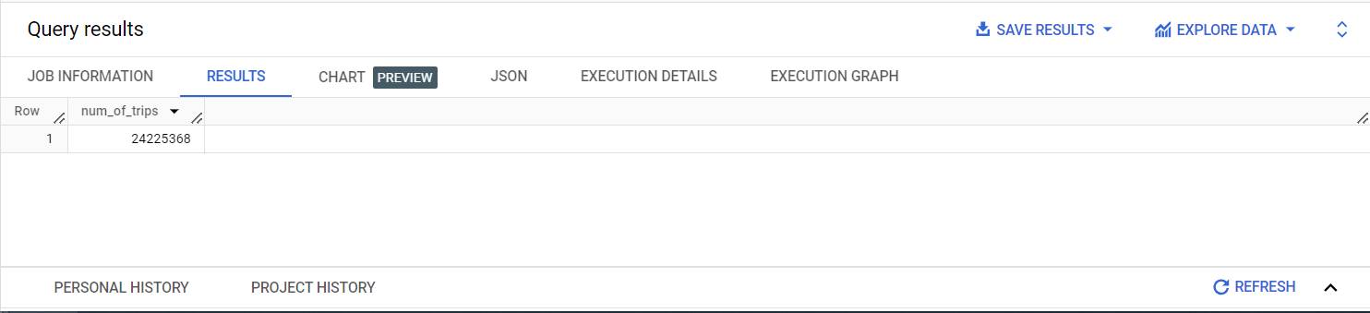

--What are the names of the stations that bike_id 1710 started from?

SELECT distinct(start_station_name )

FROM `bigquery-public-data.london_bicycles.cycle_hire`

where bike_id = 1710

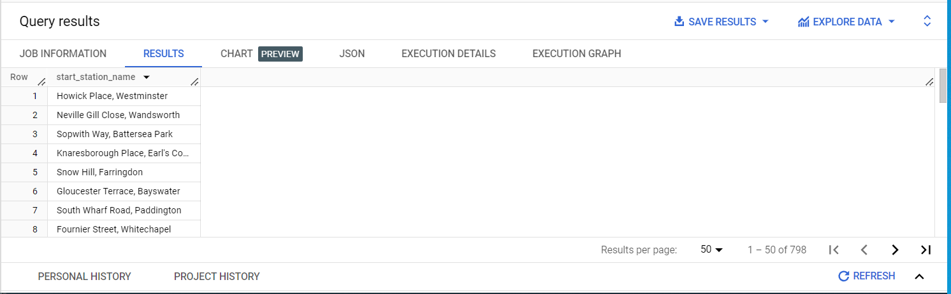

--How many bike_ids have ended at "Moor Street, Soho"?

SELECT distinct(count(*))

FROM `bigquery-public-data.london_bicycles.cycle_hire`

WHERE end_station_name = 'Moor Street, Soho'

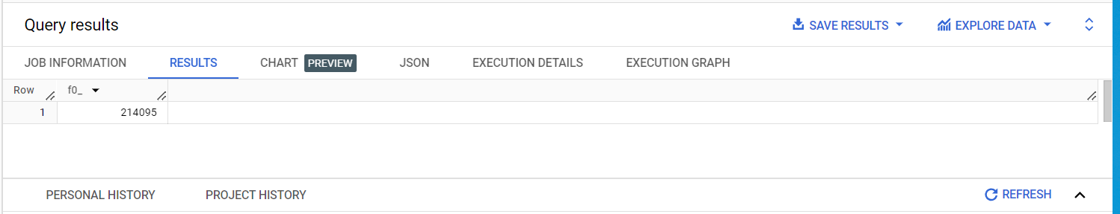

--What is the station_id for "Canton Street, Poplar"?

SELECT distinct(end_station_id), end_station_name

FROM `bigquery-public-data.london_bicycles.cycle_hire`

WHERE end_station_name = 'Canton Street, Poplar'

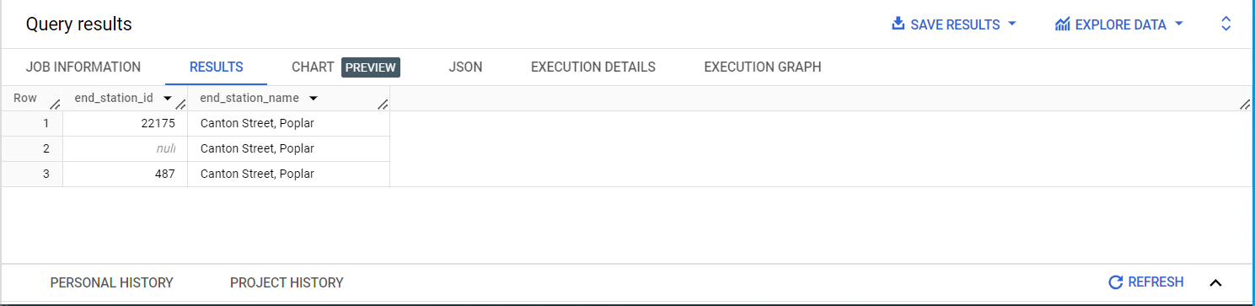

--What is the name of the station whose ID is 111?

Here, I did not know if the station ID was an end_station_id or a start_station_id. So I first ran the below query

SELECT start_station_id, start_station_name, end_station_id, end_station_name

FROM `bigquery-public-data.london_bicycles.cycle_hire`

WHERE end_station_id = 111 or start_station_id = 111

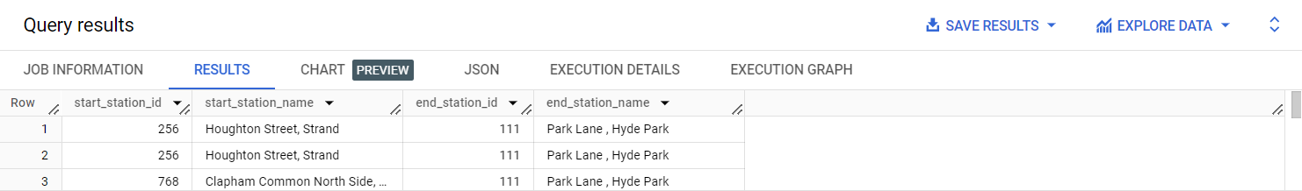

After running this query, I discovered that 111 belongs to the end station set of IDs.

SELECT distinct(end_station_name), end_station_id

FROM `bigquery-public-data.london_bicycles.cycle_hire`

WHERE end_station_id = 111

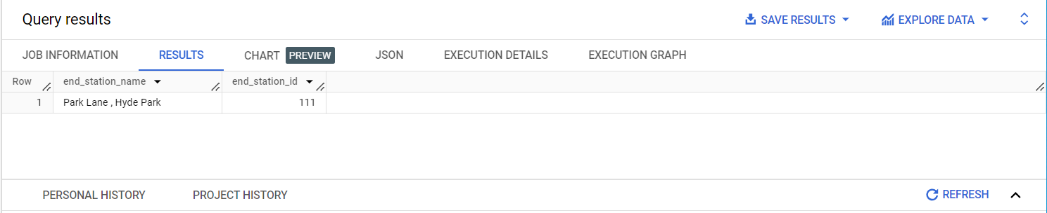

--How many distinct bike_ids had trip durations greater than 2400 seconds (or 40 minutes)?

SELECT count(distinct(bike_id))

FROM `bigquery-public-data.london_bicycles.cycle_hire`

WHERE duration>2400

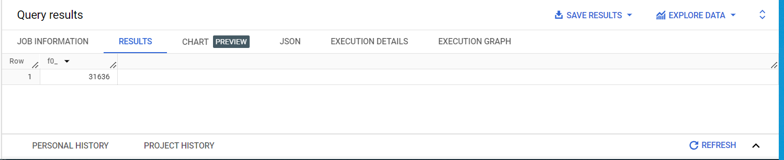

--At what station did the bike trip with rental_id 57635395 end?

SELECT end_station_name

FROM `bigquery-public-data.london_bicycles.cycle_hire`

WHERE rental_id = 57635395

